7 Performing one-way ANOVA using aov() (R).

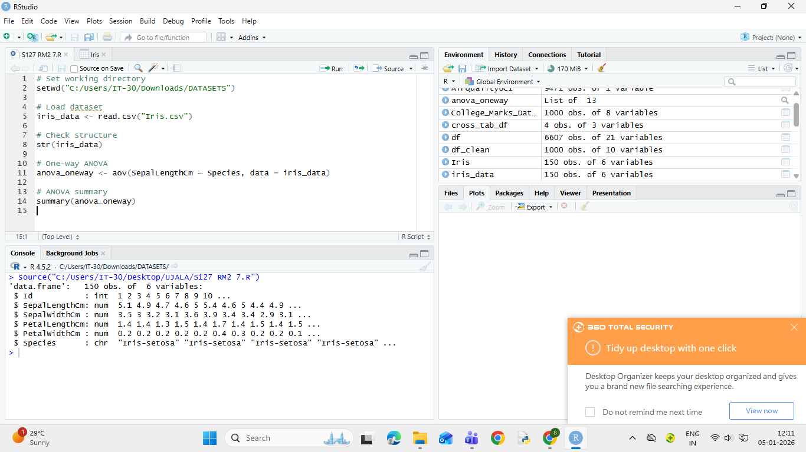

8 Performing two-way ANOVA using aov() (R).

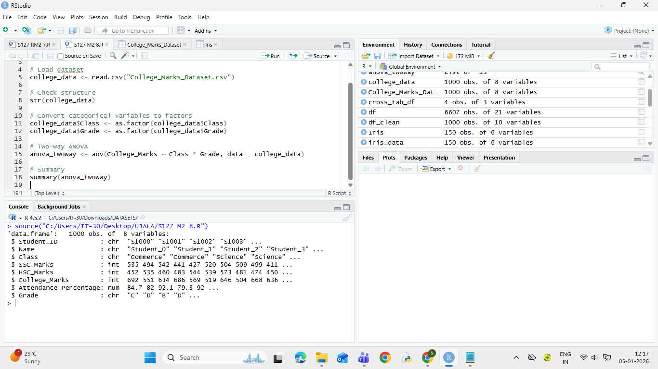
9 Conducting Chi-square tests using chisq.test() (R)

